Robotic Manipulator Simulator

Robert F.K. Martin 1505151

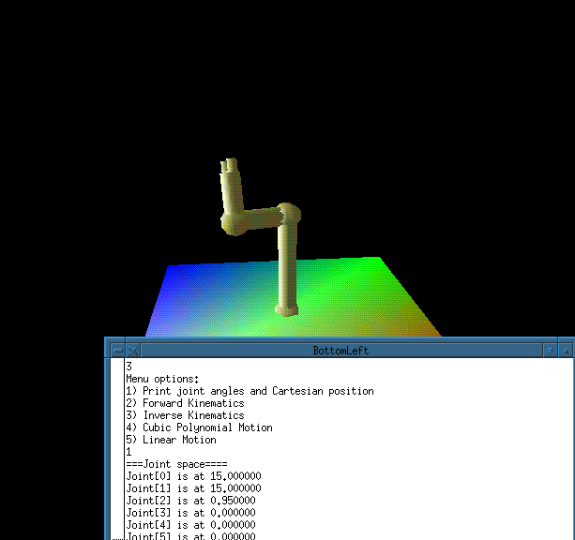

Design Documentation: 1-10 out of 10, 10%

Description of Ooooo Points and Project Chronology: 1-10 out of 10, 5%

Does the project contain all the required elements?: 1-20 out of 20, 55%

Forward Kinematics
(Implementation, End Effector Pose displayed in Cartesian Coordinates)

Joint Space Trajectory Generation with animated, smooth motion

User Interface allowing arbitrary joint angle input for trajectory

Minimum of 6 links (minimum of 2 serially connected)

Graphical display of the robot that is effective in presenting link pose

Oooo Points: 1-12 out of 10, 30%
Motivation

The motivation behind taking on this project was to create a program that would serve as an aid in learning many of the concepts in this class. When first learning DH parameters, it was difficult to ascertain whether or not the solutions one got were correct. When talking about singularities, it was easy to understand the concept and the math, but what did it look like? These problems and questions helped guide the development of this program and it is my hope that it can be extended to be someday used as a teaching aid for this and other robotics classes.

Program Organization/Flow

Truthfully, there is little organization, datawise, to this code. Almost all important variables were stored globally and no care was taken to write tight efficient code. Nonetheless, it works. And it is probably a good candidate for Microsoft production.

In terms of program flow, the user is first presented with a menu asking for a choice of robots to simulate. The choices are a Puma 560, a Yakusawa Motoman, a Stanford Manipulator, and a robot drawn through entry of DH parameters. Once a choice is made, the selection is drawn. While focus is in the robot window, the joint angles can be manipulated by using the number keys. Unmodified number keys increase the angle of the corresponding joint(‘1’ increases joint 1, etc.), shift-modified numbers decrease the angle(‘!’ decreases joint 1, etc.). Also, the user can modify the viewpoint of the camera using the keys x,y,z. Again, unmodified keys and shift-modified keys work in opposing manner. Also, the focal point of the observer can be changed with the keys a,b,c. which also work in a unmodified/modified manner.

When the user presses the left mouse button in the robot window, he is presented with a menu in the terminal window. This menu allows the user to chose a display of current joint positions and Cartesian coordinates, a new position through forward kinematics, a new position through inverse kinematics, motion using cubic polynomials with up to four via points, and linear motion.

When the user presses the right mouse button in the robot window, he is presented again with the original menu asking for a choice of robot, at which time a new robot can be chosen to simulate.

Functional Block Description

Matrix Math

Once the DH parameters are loaded, whether through user input or preset values, a series of T matrices are produced using a 4x4 array. These matrices are then multiplied serially to get the final transform for the end effector relative to the base. Also, functions were added to be able to initialize identity and zero matrices.

Inverse Kinematics for Arbitrary DH Robot

While it is nearly impossible to get an exact solution for a general DH specified robot, it is possible to get close. Given a Cartesian point in space, the inverse kinematics routine rotates each joint until the distance between the end effector and the point is minimized. Starting with joint 1 it calculates the end effector position for angles from –180° to 180°. After determining the angle that minimizes the distance to the goal, it continues to the next joint and so on. While I haven’t been able to calculate an absolute error of this method, for the robots used in this program, the repeatability is about .10 units.

Polynomial Motion

Using the solutions found in the book, given a starting and ending position, the polynomial coefficients are calculated. These are then fed to an animation routine that steps through the time and calculates new angles for each new time unit. The solution for multiple via points assumes zero velocity at the boundary.

Linear Motion

Again, given starting and ending points, a trajectory is solved for. Using this trajectory and dividing the time into discrete units, a new position is calculated for an displayed.

Chronology of Changes

For the first part of the project, my only goal was to be able to correctly display a robot given a set of arbitrary DH parameters. I took the skeleton of a program from the OpenGL Programming Guide and extended it to include more joints and links as well as shape and shading improvements. All links are represented as cylinders and joints are represented as spheres. Depth planes, double buffering, and light and material attributes, were added to the program to allow for realistic three-dimensional display of the robot.

After some time, it became tiresome to continually have to enter a set of DH parameters every time the program ran. So it became obvious that including preset, well-known robots would be a smart idea. Thus, the user can now choose from three other robots as well as the arbitrary one.

At this point, there was still no way to determine the Cartesian position of the end effector and a way to determine the T matrices was needed. Thus, matrix math was introduced.

For the second part of the project, trajectory generation was added using the cubic polynomial approach from the book. Once the code worked for a set of beginning and ending points, via points were added. I attempted to let the user choose either stopping at the via points or assume constant velocity and acceleration through the via points, but solving for the latter given an arbitrary number of via points proved too difficult.

Lastly, code for linear motion was added.

What Makes Me Special

1) There is ability to simulate a robot with arbitrary DH parameters. This includes robots with up to 10 joints, either revolute or prismatic. User input DH parameters successfully construct the robot as can be evidenced by entering the DH parameters for a Puma 560 and comparing the results.

2) There is the ability to simulate three different real-world robots. Without having to know any DH parameters, one can still observe motion.

3) The solution for the inverse kinematics of an arbitrary robot is not exact, but the error is reasonable. Improvements could have been made, such as adding gradient descent to get a more exact solution. But the costs of the extra computation time didn’t make up for the benefits gained in the better solution.

4) There is the choice of having the robot move in a linear fashion or using a cubic polynomials to calculate a trajectory between two points. This works not only for the three preset robots but also for the arbitrary robot.

